**Exercise 4: REST Country Web Service**

1. **REST Controller – CountryController**

➤ Class Level Mapping

@RestController

@RequestMapping("/countries")

public class CountryController {

private static final Logger LOGGER = LoggerFactory.getLogger(CountryController.class);

1. **Create a Country Bean with Validation**

public class Country {

@NotNull

@Size(min = 2, max = 2, message = "Country code should be 2 characters")

private String code;

@NotBlank(message = "Country name must not be blank")

private String name;

// Getters and setters

}

1. **POST Method - Add Country**

@PostMapping

public Country addCountry(@RequestBody @Valid Country country) {

LOGGER.info("Start");

LOGGER.debug("Country: {}", country);

return country; // just echoing back for now

}

1. **Global Exception Handling**

GlobalExceptionHandler

@ControllerAdvice

public class GlobalExceptionHandler extends ResponseEntityExceptionHandler {

private static final Logger LOGGER = LoggerFactory.getLogger(GlobalExceptionHandler.class);

@Override

protected ResponseEntity<Object> handleMethodArgumentNotValid(MethodArgumentNotValidException ex,

HttpHeaders headers,

HttpStatus status,

WebRequest request) {

LOGGER.info("Start");

Map<String, Object> body = new LinkedHashMap<>();

body.put("timestamp", new Date());

body.put("status", status.value());

List<String> errors = ex.getBindingResult().getFieldErrors()

.stream()

.map(x -> x.getDefaultMessage())

.collect(Collectors.toList());

body.put("errors", errors);

LOGGER.info("End");

return new ResponseEntity<>(body, headers, status);

}

}

1. **Sample CURL Commands**

curl -i -H "Content-Type: application/json" -X POST -d '{"code":"IN","name":"India"}' <http://localhost:8090/countries>

1. **Notes for PUT and DELETE**

**➤ PUT Method**

@PutMapping

public Country updateCountry(@RequestBody @Valid Country country) {

LOGGER.info("Start");

LOGGER.debug("Updated Country: {}", country);

return country;

}

**➤ DELETE Method**

@DeleteMapping("/{code}")

public void deleteCountry(@PathVariable String code) {

LOGGER.info("Deleted country with code: {}", code);

}

**Valid POST Request**

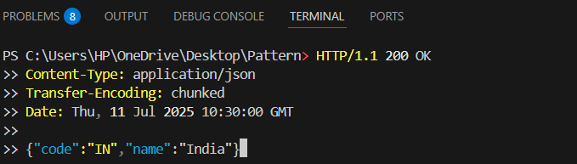

**Valid PUT Request (Update Country)**

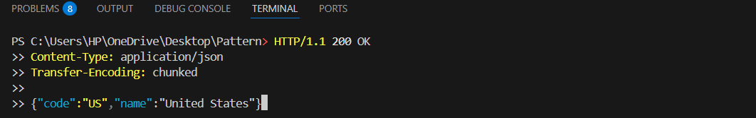

**DELETE Request**

